Fee Structure 2020-21 for B.Sc. H&HA
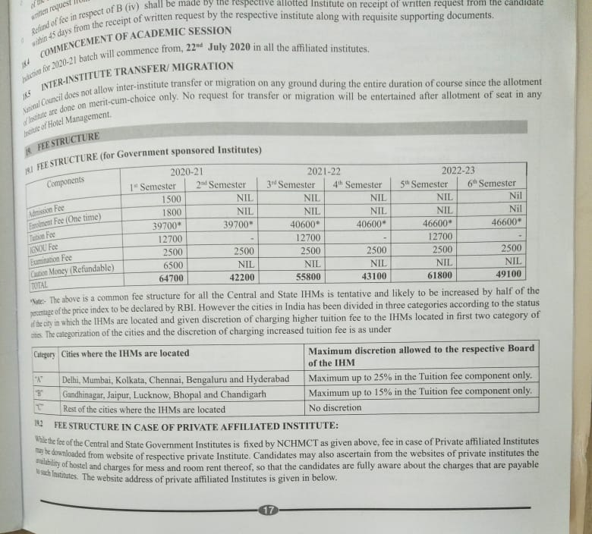

- Additional Fee: Rs.17,000/- approx. (one time payment)
- Hostel Fee for both Boys and Girls: Rs.35,000/- per semester which includes (boarding and lodging) and limited laundry.

