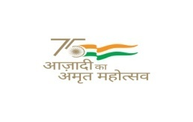**INSTITUTE OF HOTEL MANAGEMENT**



**DEHRADUN INFORMATION BULLETIN**

Admission in B.Sc. (H&HA) Course 2022-23

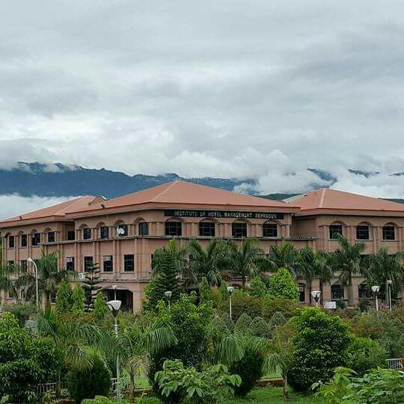

**INSTITUTE OF HOTEL MANAGEMENT DEHRADUN**

*(An Autonomous Body under the Ministry of Tourism, Government of India)*

IHM Dehradun, Near ONGC Helipad, Nimbuwala, Garhi Cantt., Dehradun

Tel: +91 9410394200 Tele- 0135-2550339

Website: [www.ihmddn.com](http://www.ihmddn.com)

Mail: [ihmdehradun@gmail.com](mailto:ihmdehradun@gmail.com) Academic Mail: ihmddn.help@gmail.com

**About Us**

In view of the potential of tourism development in Uttarakhand State, the Government of India and State Government felt that there was a pressing need of an Institute of Hotel Management Catering Technology and Applied Nutrition. Dehradun being an ideal location for the purpose in view of the existing and available facilities, it was decided by the then Hon'ble Minister of Tourism and Culture Sri Jagmohan during his visit to Dehradun on 11.06.2002 to establish Institute of Hotel Management Catering Technology and Applied Nutrition. The State Government allocated 25 acres of land for the purpose. Accordingly, inauguration and stone laying ceremony was consummated on 14.10.2003 at the allotted site.

# 3 Years B.Sc. Hospitality and Hotel Administration Program

The Bachelor of Science program in Hospitality and Hotel Administration is offered jointly by the National Council for Hotel Management and the Indira Gandhi National Open University. The Three-Year (Six Semester) course equips students with all the required skills, knowledge and attitude to efficiently discharge supervisory responsibilities in the Hospitality sector. The program involves in-depth laboratory work for students to acquire required knowledge and skill standards in the operational areas of Food Production, Food & Beverage Service, Front Office Operation and House Keeping. It also provides managerial inputs in Hotel Accountancy, Food Safety & Quality, Human Resource Management, Facility Planning, Financial Management, Strategic Management, Tourism Marketing and Management.

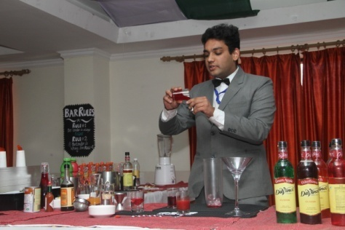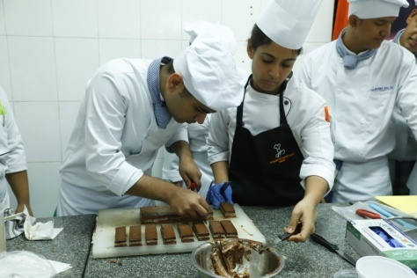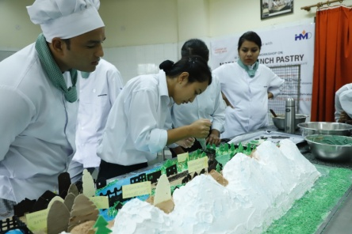

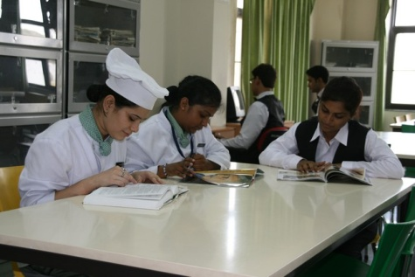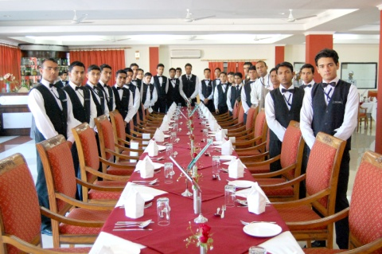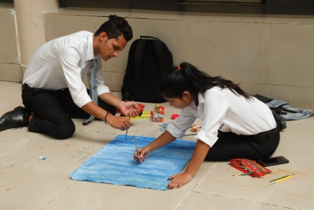

***NCHM Counseling Schedule 2022***

|  |  |
| --- | --- |
| **COUNELLING SCHEDULE**  **e-Counseling for Admission to B.Sc.(H.H.A.) 2022-23**  **(Payment and Documents verification through ONLINE only, no physical reporting is required during Counseling)** | |
| **EVENTS OF COUNSELLING** | **B.Sc.(HHA)** |
| **First Round** Online Registration (Registration Fee Rs.2000/-) | 09.07.22 - 13.07.2022 |
| Choice Locking (If Finally agreed) | 12.07.22 - 13.07.2022 |
| **First Round Seat Allotment Result** | **14.07.2022** |
| Payment of Seat Acceptance Fee (Rs.20,000) and uploading req. Doc. | 15.07.22 - 19.07.2022 |
| If Query raised by Document Verification Center (DVC), resolve on portal | 15.07.2022 - 19.07.2022  upto 5.00 evening |
| Verification of Documents by DVC |
| Withdrawal through portal only | 19.07.2022 (upto 5.00  p.m.) |
| Vacancy after First Round Allotment | **20.07.2022 (Evening)** |
| **Second Round of Counseling** | |
| Fresh Registration(Reg. Fee Rs.2000/-) who have not registered in first rounds | 21.07.22 - 23.07.2022 |
| Choice Filling/ Modification & Locking | 21.07.22 - 23.07.2022 |
| **Second Round Seat Allotment Result** | **25.07.2022** |
| Payment by new candidate - Seat Acceptance Fee (Rs.20,000) and uploading  require documents | 26.07.2022 - 29.07.2022 |
| If Query raised by Document Verification Center (DVC), resolve on portal | 26.07.2022 - 29.07.2022  upto 5.00 p.m. |
| Verification of Documents by DVC |
| Withdrawal through portal only | 26.07.2022 - 29.07.2022 (5.00pm) |
| Vacancy after Second Round Allotment | **30.07.2022 (Evening)** |
| **Third Round of Counseling** | |
| Fresh Registration(Reg. Fee Rs.2000/-) who have not registered in earlier rounds | 01.08.2022 - 04.08.2022 |
| Choice Filling /Modification & Locking | 01.08.2022 - 04.08.2022 |
| **Third Round Seat Allotment Result** | **05.08.2022 (Evening)** |
| Payment by new candidate - Seat Acceptance Fee (Rs.20,000) and uploading  require documents | 06.08.2022 - 08.08.2022 |
| If Query raised by Document Verification Center (DVC), resolve on portal | 06.08.2022 - 08.08.2022  upto 5.00 p.m. |
| Verification of Documents by DVC |
| **FINAL Withdrawal** through portal only | **08.08.22** upto 5.00p.m |
| Vacancy after Third Round Allotment | 09.08.2022 **(Evening)** |
| **Final & Admission Close Round (**There is no Withdrawal/quit facility from seat) in this Final round) | |
| Fresh Registration & Participation Fee Payment | 10.08.2022-12.08.2022 |
| Choice Filling option and Modification | 10.08.2022-12.08.2022 |
| **Final Round Seat Allotment Result** | **13.08.2022** |
| For new candidate – uploading of required documents | 14.08.2022-16.08.2022 |
| If Query raised by Document Verification Center (DVC), resolve on portal | 14.08.2022-16.08.2022 |

|  |  |
| --- | --- |
| Verification of Documents by DVC | 14.08.2022-17.08.2022  upto 05.00 p.m. |
| **Admission Closed** | |
| Physically Reporting/ Induction Program at Allotted Institute | 18th – 22nd Aug. 2022 |
| Allotment of Hostel Seats **by NIC** - As per merit of candidate and availability | 22nd Aug. 2022 |
| **Commencement of Classes for batch 2022-23** | **1st September, 2022** |

# Seat Matrix - 2022

|  |  |  |  |  |  |  |  |  |  |  |  |  |
| --- | --- | --- | --- | --- | --- | --- | --- | --- | --- | --- | --- | --- |
| **Program** | **Open** | **Open PwD** | **General- EWS** | **General- EWS**  **PwD** | **OBC** | **OBC**  **PwD** | **SC** | **SC**  **PwD** | **ST** | **ST**  **PwD** | **Kashmiri Migrant** | **Total Seats** |
| **B.Sc in Hotel Management** | **109** | **6** | **0** | **0** | **0** | **0** | **21** | **1** | **10** | **0** | **1** | **148** |

**Fees Details**

* **ADDITIONAL FINANCIAL COMPONENT**

|  |  |  |
| --- | --- | --- |
| **Sr. No.** | **AMOUNT (In Rs.)** | **PARTICULARS** |
| 01. | 71,000/- | * Admission Fees - 1500/- * Enrollment Fees - 1800/- * Tuition Fees - 39,700/- * Examination Fees - 2500/- * Caution Money - 6500/- * College Uniform - 12000/-   & Kitchen Toolkit   * Misc. Fees - 5500/- * Logbook & Journals - 1000/- * Medical Fees - 500/-   Note: In addition to above, the student has to enroll in IGNOU Portal with the help of Institute and pay the IGNOU fees of Rs.12,700/- |
| 03. | **Hostel Fees**  35,000/-* per semester | `. 35000/- Hostel Fees  (Food and Limited Laundry) |

***Uniforms Details***

## The following Uniform & Toolkit provided by the Institute

* + Formal White Shirt - 2 nos.
  + Formal Black Trouser (Color Tone Jet Black) (Pleated) - 2 nos.
  + Winter Coat - 1 no.
  + Pullover Full - 1 no.
  + Lab Coat White - 1 no.
  + Chef Coat - 2 nos.
  + Waist Coat - 1no.
  + Tie (color decided by the Institute) - 1 no.
  + Bow Black - 1 no.
  + Name Tag - 1 no.
  + Chef Cap - 2 nos.
  + Flat Cap - 1 no.
  + Apron - 2 nos.
  + Kitchen Scarves - 1 no.
  + Kitchen Duster - 4 nos.
  + Damask Napkins - 5 nos.
  + Buffing Cloth - 2 nos.
  + Chef Knife - 1 no.
  + Peeler S.S. - 1 no.
  + Veg. Knife - 1no.
  + Pairing Kife - 1 no.
  + Whisker S.S. - 1 no.
  + Icing bag with Nozzle - 1 no.
  + Silicon Spatula Medium - 1 no.

**NOTE: - Please refer the photograph of the shoe.**

Shoes to be bought from your side (Oxford Rounded Black Shoe)



***IHMD Hostel* Allotment *Procedure***

## ACCOMMODATION BOYS & GIRLS

* Hostel Allotment for the Boys & Girls will be declared as per the JEE rank based policy.
* Hostel Accommodation for Boys includes Dormitory, Single, Double and Triple occupancy having a Bed, a Mattress, a Cupboard, a Writing Table, a Chair, common Toilet & bathroom facility, lots of outdoor sports activities etc.
* Hostel Accommodation for Girls includes Double and Triple occupancy having a Bed, a Mattress, a Cupboard, a Writing Table, a Chair, common Toilet & bathroom facility, lots of outdoor sports activities etc.
* Rooms allotment will be done as per the JEE rank policy and will be applicable in the allotment of rooms.
* Fees include charges of Accommodation, Meals (Breakfast, Lunch on weekends, Evening Tea, and Dinner) & Limited Laundry.

## Hostel Seat Matrix

|  |  |
| --- | --- |
| **Hostel** | **OPEN** |
| Boys | 80 |
| Girls | 30 |

Institute of Hotel Management Catering Technology and Applied Nutrition, Near Tapkeshwar Temple, Garhi Cantt., Dehradun. PH.: 0135-2550272, 2550339, E-mail address: [ihmdehradun@gmail.com](mailto:ihm-ddn@hotmail.com), [www.ihmddn.com](http://www.ihmddn.com)